Question 2
In this mini-case you will complete the preliminary analytical procedures for the 2016 audit of EarthWear Clothiers, Inc.

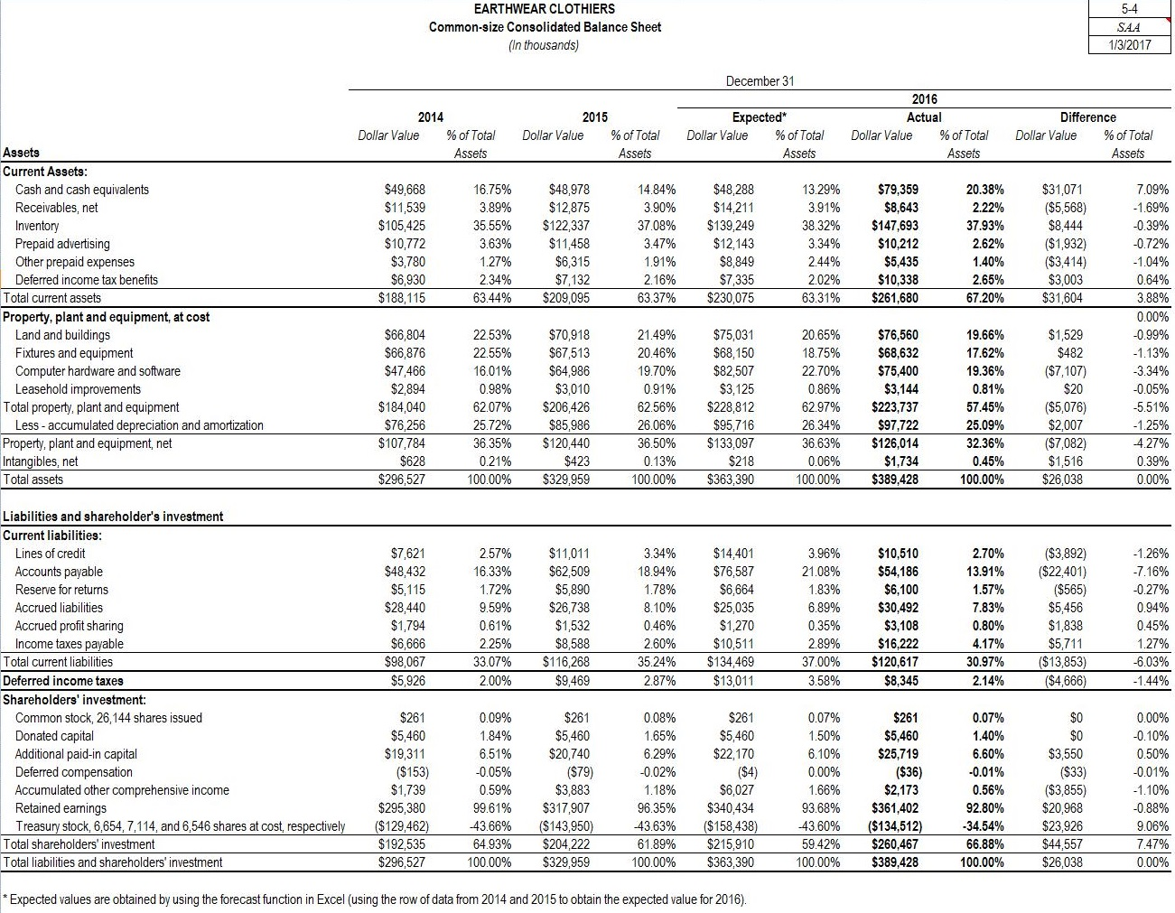

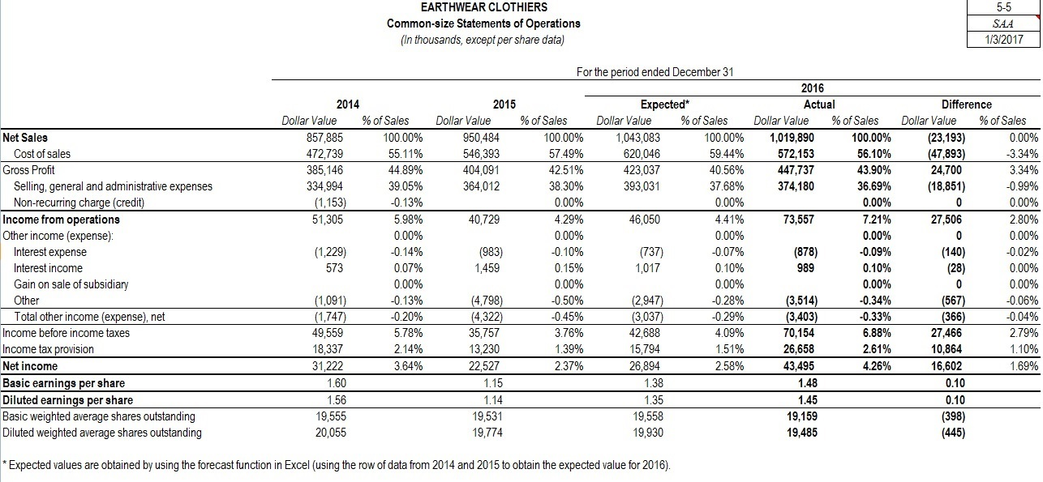

Review the ratio analyses contained on Work Paper 5-1. You can read the Advanced Module: Selected Financial Ratios in Chapter 5 of the text for a description of these ratios.You will be asked to provide further analyses of these ratios as you complete Work Paper 5-2.

Work Paper 5-1
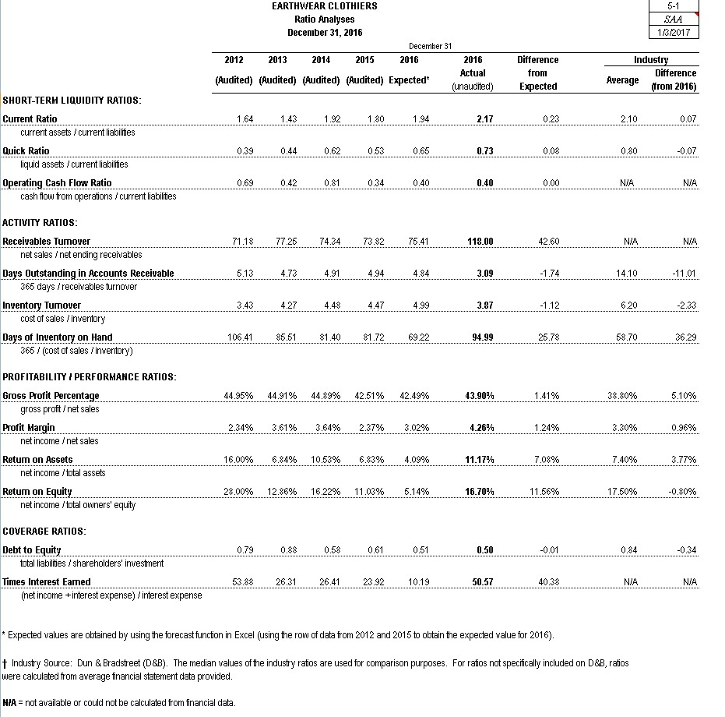
Complete all the fields on Work Paper 5-2 indicated below. Additionally, EarthWear Common-Size Financial Statements have been included to aid you in your decisions.
Work Paper 5-2

EARTHWEAR CLOTHIERS
Preliminary Analytical Procedures
Summary of Ratio Analyses & Assessment of Financial Condition
December 31, 2016

1. Comments and Summary
Based on your review of Work Paper 5-1, list one or two ratios in each of the following categories that you believe increase the risk of potential misstatement. Explain why you believe the risk is increased and identify possible causes of a potential misstatement and indicate if you believe the auditor would need to revise his or her typical audit approach to address the risk.

For example, "Days of Inventory on Hand" increased significantly indicating merchandise is held in inventory for a longer period than prior years and it is also held for a longer period than the industry average. This increases the risk of obsolete inventory and/or the market value dropping below recorded cost. The auditor should increase the extent of inventory-valuation testing and/or change the nature of the testing to address the increased risk.

Explanation
SHORT-TERM LIQUIDITY RATIOS:

Student Answers will vary. Possible responses include: Current Ratio - increased higher than expected. Driven by higher than expected current assets and lower than expected current liabilities. Raises the risk of overstatement of assets and understatement of liabilities. The increase in current assets is due largely to increases in cash and inventory. Planned procedures in these areas are likely adequate. Decrease in liabilities due to decreases in Lines of credit and Accounts Payable. Auditor might consider revising the extent and nature of testing in accounts payable due to the understatement risk. Auditor would need to understand the client's explanation and revise the plan accordingly.
ACTIVITY RATIOS:
Student Answers will vary. Possible responses include: Inventory Turnover - decreased significantly indicating merchandise is held in inventory for a longer period than prior years and for a longer period than industry average. This increases the risk of obsolescence and/or the market value dropping below recorded cost. The auditor should increase the extent of inventory-valuation testing and/or change the nature of the testing to address the increased risk. Receivable Turnover - increased higher than expected. Sales increased by approximately 7% while AR decreased by about 5%. This indicates that receivables are being collected at a much quicker pace, but also raises the risk of sales overstatement. The auditor should understand the cause of changes, particularly new collection procedures and consider if additional testing is necessary.
PROFITABILITY / PERFORMANCE RATIOS:
Student Answers will vary. Possible responses include: Profit Margin - increased significantly compared to prior years and the industry. This increases risk of revenue and cost recognition and cut-off issues. The auditor should probably increase the rigor and precision of the disaggregated substantive analytical procedures, investigate if any recognition accounting policies changed, and possibly increase fraud related testing. Return on Equity - increased more than expected, due largely to higher gross margin (see discussion on "Gross Margin" above), and significant reduction in Selling, General & Admin costs. Raises potential risk of period vs. product costs (i.e., SG&A not being recorded as a period cost in proper period). Auditor should understand the cause of the fluctuation and potentially increase testing of classification and timing of expense recognition.
COVERAGE RATIOS:
Student Answers will vary. Possible responses include: Times Interest Earned - Increased dramatically which increases the risk that pretax income is overstated and/or that some interest payments or even debt may not have been properly recorded. As noted above, increased attention on revenue and profitability is warranted. Current audit plan for interest income is probably sufficient so long as the completeness assertion regarding debt is adequately addressed.

2. Assessment of Financial Position

Based on your review of Work Paper 5-1, assess the client's ability to continue as a going concern (to stay in business) by responding to the following questions.

A. Identify ratios and trends, if any, that cause concern about the client's ability to continue as a going concern.

Essay 5Edit Unavailable.In 2015 there was an increase, however, in the industry average, which is not a good sign regarding the payment of its obligations. The following accounts were generated at a bad turnover compared to the previous month, but higher than the industry media or that show the inefficiency of the business operation and the concern to continue operating. The high probability that the coverage indexes contain major material distortions concern about the company's ability to continue operating.

2. Assessment of Financial Position
A. Student Answers will vary. Possible responses include: The increase to "Days of Inventory on Hand" and the significant difference between EarthWear's ratio and the industry average raised the risk of obsolescence as noted above and also suggests that the client has more cash tied up in inventory than its competitors. Changes in clothing trends and fashions could result in significant losses due to inventory obsolescence.
B. Student Answers will vary. Possible responses include: The "Receivables Turnover" and "Days Outstanding in Accounts Receivable" ratios are far better than industry average. The company has an effective collection process, increasing cash available for operations and capital expenditures.
C. High probability that the company will successfully continue in business for at least one year and be able to pay its debts as they become due.

D. Student Answers will vary. The company has increasing sales, improving profit margins, decreasing Selling, General and Admin. expenses, a significant amount of cash, and has decreased current liabilities (reflected in the dramatic increase in "Times Interest Earned" ratio). The company has no long-term debt.

