In this mini-case you will complete the preliminary analytical procedures for the 2016 audit of EarthWear Clothiers, Inc.

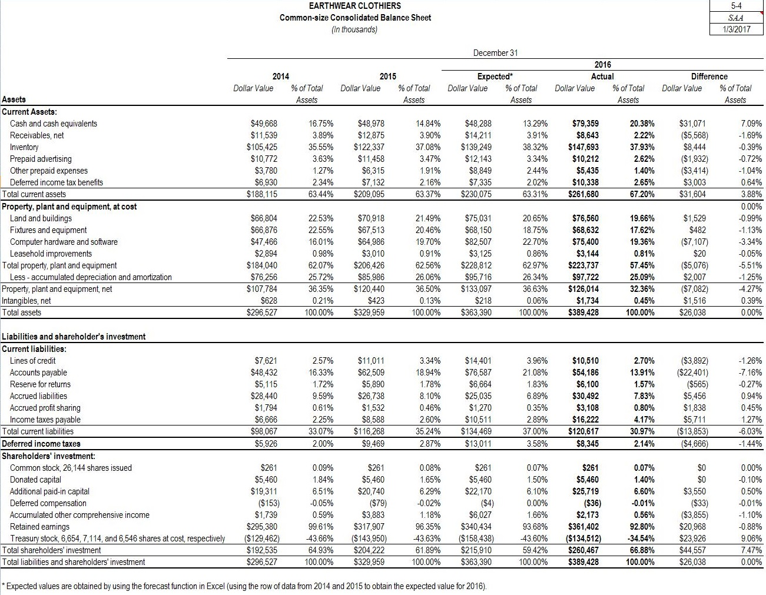

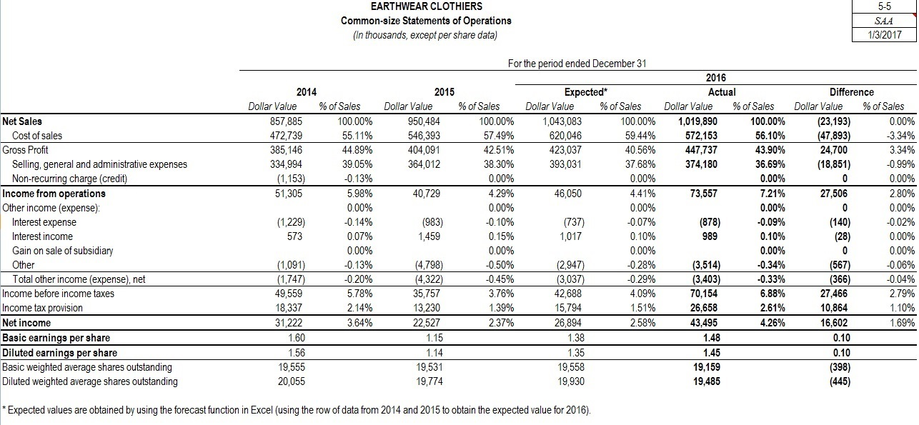

Review the ratio analyses contained on Work Paper 5-1. You can read the Advanced Module: Selected Financial Ratios in Chapter 5 of the text for a description of these ratios.You will be asked to provide further analyses of these ratios as you complete Work Paper 5-2.

Work Paper 5-1
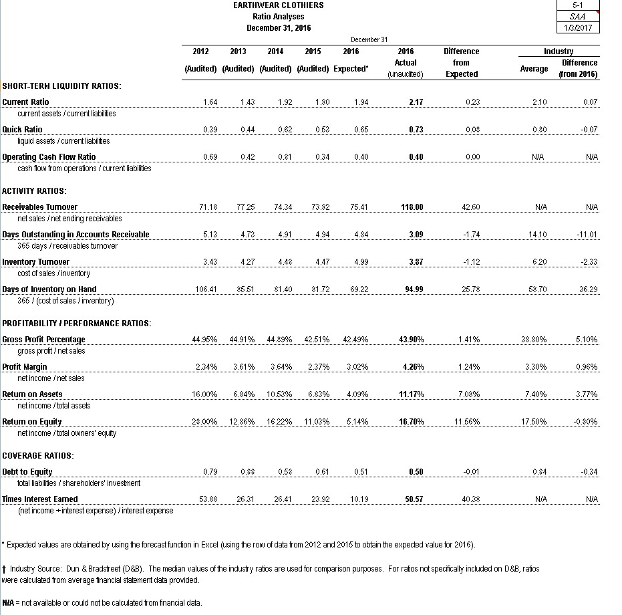
Complete all the fields on Work Paper 5-3 below. Additionally, EarthWear Common-Size Financial Statements have been included to aid you in your decisions.

Work Paper 5-3
EARTHWEAR CLOTHIERS
Identification of Accounts with Unexpected Fluctuations
December 31, 2016

1. Establish Threshold for Unexpected Fluctuations
To begin identifying accounts with unexpected fluctuations auditors must establish a threshold for account difference. All accounts whose actual 2016 unaudited account balance differs from the expected balance by a value greater than the threshold established will be shown in the charts below. As a general rule the threshold should not exceed materiality. For the purposes of this exercise we assume planning materiality is $3.1 million. (Omit the "$" sign in your response.)

A. Set threshold for account difference in thousands $ 3,100 Numeric ResponseEdit Unavailable. 3,100 correct.

2. Evaluate Threshold for Unexpected Fluctuations
Lists of Balance Sheet and Income Statement accounts have been generated below based on your threshold for account difference. In the "Evaluation" column please identify 1 or 2 balance sheet and 1 or 2 income statement accounts where you believe the difference presents increased risk of material misstatement that may require a change in the nature, timing or extent of planned audit procedures. Please indicate possible reasons for the difference, potential risks, and suggested audit plan revisions.

Explanation
Cash and cash equivalents $31,071 - Cash will tend to fluctuate based on timing of receipts and disbursements. Presents no additional risks, current audit plan adequate for cash balance.
Receivables, net ($5,568) - Receivables decreased while sales increased dramatically. Investigate change in collection process and revise plan to address new processes and procedures. This may involve disaggregated analytical procedures that will illustrate improvement in collection during the period after any policy changes took place.
Inventory $8,444- As noted on Work Paper 5-2, the significant increase in inventory increases the risk of obsolescence and/or the market value dropping below recorded cost. The auditor should increase the extent of inventory-valuation testing and/or change the nature of the testing to address the increased risk.
Other prepaid expenses ($3,414)-The decrease in other prepaid expenses increases the risk of cutoff and whether the accrual includes all disbursements for the period, however, the typical audit procedures in this area are likely sufficient.
Computer hardware and software ($7,107)-The difference indicates that significant quantities of computer hardware and software may have been liquidated. Increased testing regarding disposals, gains/losses probably warranted.
Lines of credit ($3,892)-Decrease doesn't raise additional risk given the cash available. Current audit plans are sufficient.
Accounts payable ($22,401)-Decrease doesn't raise additional risk given the cash available. Current audit plans are sufficient.
Accrued liabilities $5,456- The increase raises the risk of cut-off and matching errors in calculating accruals. Additional testing in this area will probably be required.
Income taxes payable $5,711- Risk lies with "income tax provision" expense account, see discussion below.
Deferred income taxes ($4,666)-Deferred income taxes presents significant risk due to the complexity of the underlying calculations. Current approach to test controls and involve tax professionals is adequate to address the risk.
Additional paid-in capital $3,550 -Increase due to issuance of Treasury Stock, no additional risk presented and audit plan is sufficient.
Accumulated other comprehensive income ($3,855)- Account is prone to fluctuations. Current audit plan incorporates reporting and classification risks.
Treasury stock, 6,654, 7,114, and 6,546 shares at cost, respectively $23,926-Likely the result of sale of Treasury Stock. No additional risk presented and audit plan is sufficient to detect any material errors.

B. Income Statement Accounts
Net Sales ($23,193) -Sales grew less than expected based on the trend over the last couple of years. No additional risks presented. Current audit plan will be sufficient.
Cost of sales ($47,893)- Cost of Sales grew less than expected. Increased risk that inventory sold wasn't relieved to cost of sales or that not all costs were captured in the system. Additional testing relating to inventory costing system, cut-off and expense recognition warranted.
Selling, general and administrative expenses ($18,851)-Expenses grew less than expected. No additional risks presented. Current audit plan will be sufficient.
Income tax provision $10,864- Significant change may be due to change in tax law or tax strategy. Tax accountants should review the company's new strategy or assumptions.

