Multiple Choice

Use the following information for questions 1 through 3:
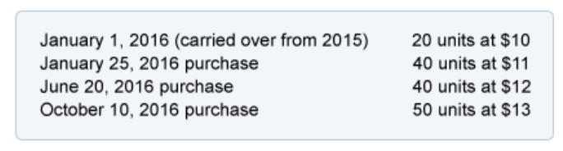
A company purchased merchandise to be resold at increasing costs during the year 2016. The purchases were made at the following costs...
The company sold 10 items at the end of each month.
- What are the number of units and the cost of the goods available for sale?
____________ units $_____________ cost of goods available for sale.

- Assuming the LIFO periodic cost flow assumption, what will be the company's cost of goods sold for the 120 items sold in 2016?

  - $1,380
  - $1,386
  - $1,400
  - $1,460

- Assuming the FIFO periodic cost flow assumption, what will be the company's cost of goods sold for the 120 items sold in 2016?

  - $1,380
  - $1,386
  - $1,410
  - $1,460

