

DEPARTMENT OF CHEMISTRY
UNIVERSITY OF GHANA, LEGON
CHEM 114 - FOUNDATION CHEMISTRY II
TUTORIAL SET II, 2019/2020
- Give four examples of organic compounds and their sources.
- Arrange the following compounds in order of increasing boiling point.
- 3-methylhexane
- 2,2,3-trimethylbutane
- Heptane
- 2,3-Dimethylpentane
- In each pair of compounds, which compounds has the higher boiling point? Explain your choice.
- Octane or 2,2,3-trimethylpentane
- 2,2,5-trimethylhexane or nonane
- Nonane or 2-methylheptane
- i. Give four examples of fuel additives that can be used to increase the octane number of petrol
ii. Explain the following terms;
- Engine knocking
- Pyrolysis
- Reforming
- Octane number
- Write a balanced equation each for the complete and incomplete combustion of cyclopentane
- Compound X is a derivative of the natural product aflatoxin B₁

- Name all the functional groups present in compound X
- Determine the number of sp³, sp² and sp hybridized carbons in compound X
- Indicate all the primary, secondary, tertiary and quaternary carbons atoms in compound X
- Draw structures for the following compounds
a. 4-t-butyl-2-2-dimethylheptane
b. 5-isopropyl-3, 3, 4-trimethyloctane
- Name the following compounds below
- Identify the alkanes corresponding to each of the drawings
- Draw the most stable chair conformation of
a. Ethylcyclohexane
b. Isopropyl-1,1-dimethylcyclohexane
c. Cis-1-tert-butyl-4-isopropylcyclohexane
- The following names are all incorrect or incomplete, but they represent real structures. Draw each structure and name it correctly.
- 2-cyclohexylbutane
- 2,3-dimethylcyclopentane
- 5-chloro-4-methylhexane
- 3-isopropylhexane
- a. Draw structures of all constitutional isomers and give their IUPAC names for the alkane with formula C₇H₁₆.
- In each case, label the primary, secondary and tertiary carbons.
- Construct a graph of the torsional energy diagram using Newman projection for 3-methylpentane along the C₂-C₃ bond. Show the dihedral angle for each step. Indicate which conformations are the most stable and least stable.
- Write the IUPAC names of the following alkanes.

- Indicate the type of isomerism (constitutional, positional, functional, conformational or geometric) between any pair of compounds below.

- The compound Ritonavir is antiviral medicine that prevents human immunodeficiency virus (HIV) from multiplying in your body
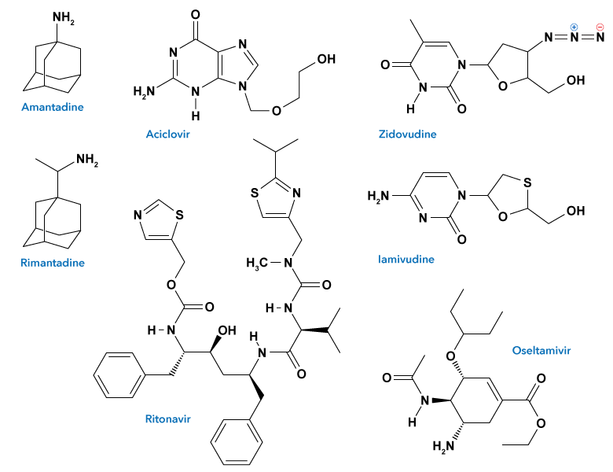

- Circle and name all the functional groups present in Ritonavir
- Determine the number of sp³, sp² and sp hybridized carbons in Ritonavir
- Indicate all the primary, secondary, tertiary and quaternary carbons atoms in Ritonavir
- Explain the following terms with respect to the halogenation of alkanes
  - Homolytic cleavage
  - Initiation step
  - Chain propagation step
  - Chain termination step
  - Radical
- Show mechanisms for the formation chloromethane starting with methane.

